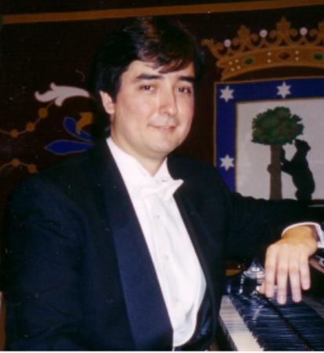

Spanish born pianist Felipe José Ramirez is widely regarded as one of the most unique talents of his generation. He is highly in demand as a soloist worldwide, and has performed throughout the United States, Central America, Spain, France, Italy, Philippines, and Indonesia. Highlights of his extensive performing career include a televised concert from Rizal Park, Manila on the 50th anniversary of United Nations Day, a Christmas concert at the Vatican a fundraising concert for the earthquake victims in El Salvador, and an homage concert in memory of the victims of terrorism in Madrid, Spain. He has presented the closing program of Spanish music for the festival at the University of Texas-San Antonio in commemoration of the 400th anniversary of the publication of Don Quijote. He was invited to appear as soloist in the inaugural concert of the newly formed Flower Mound Symphony Orchestra as well as in the UNESCO Hall in Haiti.

He has won several prizes in national and international competitions and has been invited as a jury member of the VIII National Piano Competition “Ciudad de Melilla”, Spain and the Music Competition for Young Artists Foundation in Manila, Philippines.

Despite his extensive and varied repertoire, Felipe has a special love for the music of Spanish composers. He has represented Spain in international festivals of music in Dallas, Houston, and Oklahoma. He was the first Spaniard to be invited to participate in the International Hispanic Festival held in Dallas, Texas with the Dallas Symphony Orchestra. His performance of the Concerto No. 1 in Eb by Franz Liszt earned him a standing ovation.

Felipe is also well-known as a composer. His solo disc, “Live From Texas” includes his composition “Recuerdos de Ubay” which was commissioned for the Philippine Centennial. For his achievement, he was awarded the honor of being named “Outstanding Young Artist” in the Philippines. As a composer, Felipe wrote the soundtrack for the short computer-animation film “Pawn” by ImagineAsia Co. His concert overture “Ballade de El Cid Campeador” received its world premier performance by the Meadows Symphony Orchestra in Dallas, Texas. For his contributions, Felipe was named “Musician of the Year” by the Greater Dallas Asian American Chamber of Commerce. Felipe is a member of ASCAP and the National Association of Composers-USA, Texas chapter, and he will be presenting the music of several of his Texas colleagues, as well as his own music in the opening concert of this association.

Felipe has also made several recordings, including two for Christmas with soprano Karen Maley; “Imagine,” which consists entirely of original compositions for the piano; and a solo recital entitled “Live From Carpenter Hall.” He most recently recorded the complete “Goyescas” by Enrique Granados which was selected by WRR Radio to launch a CD together with the Meadows Museum in commemoration of the opening exhibit Fortuny to Picasso. Felipe’s current recording project will feature a selection of his own compositions.

Felipe is a graduate with honors (Master of Music and Artist Certificate) of Southern Methodist University in Dallas, Texas. While at SMU, he studied piano with Joaquin Achucarro and Alfred Mouledous, and composition with Simon Sargon. Previously, he also was a student of Vladimir Viardo at the University of North Texas at Denton. There he completed the program “Musicians of the World,” and was named on the Dean’s List for outstanding academic achievement, and is a member of the Golden Key National Honor Society.

Felipe is also an accomplished photographer, painter and poet. He has been awarded as a distinguished member of the International Society of Poets, and his poetry has been published in America at the Millennium. His prize-winning photographs in the anthology Innocent Dreams. Felipe is also cofounder of Figaro Academy of Music in Dallas and Irving.

